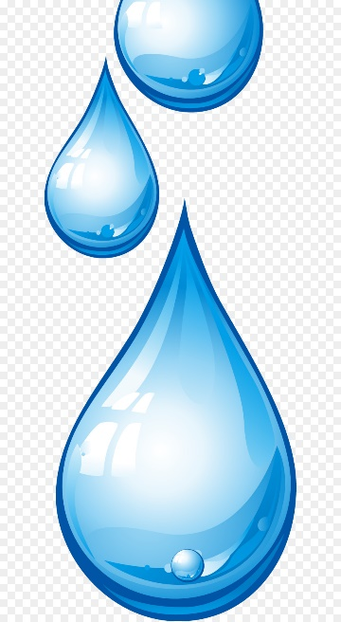
Clonkeen College Green – Schools
Top 5 Water Saving Tips
- Always turn off the tap while washing your teeth. By turning off the tap in the morning/before bed-time you can save up to 8 gallons of water.
- According to the EPA the average shower taken is 8 minutes long. Just shortening your shower by 1 minute will save 150 gallons a month.
- At home ensure kettles, dishwashers and washing machines are filled to capacity this will save both water and energy.
- Invest in a re-usable aluminium water bottle, instead of buying single- use plastics.
- Think of simple ways to re-use water at home. E.g. collect rainwater in the garden to water plants.

